CENTRELINE TEA BROKERS LIMITED MOMBASA

# THE KENYA CROP AND WEATHER WEEK UPTO 30TH SEPTEMBER 2025

# EAST OF RIFT

# KIAMBU/MURANGA/NYERI/MERU/KIRINYAGA

Rainfall was recorded over few parts of this region.

Mornings were cloudy, giving way to sunny intervals for the rest of the day. Afternoon showers were experienced over few places. Nights were partly cloudy.

Both daytime (maximum) temperatures and night-time (minimum) temperatures increased over most stations.



Crop harvest decreased.

# WEST OF RIFT

# NANDI/KERICHO/BOMET/KAKAMEGA/KISII

Some parts of the Highlands West of the Rift valley and Lake Victoria Basin received rainfall.

Sunny intervals were experienced in the mornings though occasional rains were recorded over few places. Afternoon showers and thunderstorms were experienced over few places. Night showers were recorded over few places. Some parts of this region recorded hailstorms.

Both daytime (maximum) temperatures and night-time (minimum) temperatures increased over most stations.

Crop harvest declined.

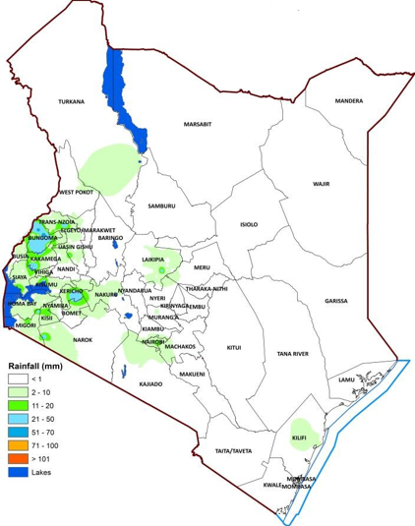

**30th September 2025**